Chapter 18, Problem 42.

Obtain the current i_{o}(t) in the circuit in Fig. 18.44.

- Let i(t) = sgn(t) A.
- Let i(t) = 4 [ u(t) - u(t - 1) ] A.

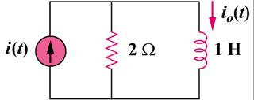

Figure 18.44
For Prob. 18.42.

